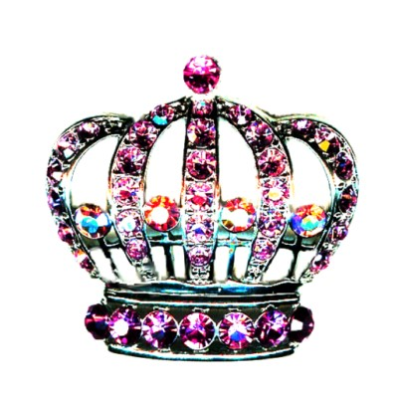
Glitzy Girls of Texas
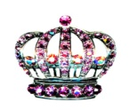
Registration Form
Contestant Information:
Contestant Name: _________________________________________________________________
Parent(s) of Contestant: _____________________________________________________________
Address: _________________________________________________________________________
Phone: ________________________ Email: ____________________________________________
Pageant Division (Please Circle One):
Baby Miss (0-11mo) Tiny Miss (12-23mo) Toddler Miss (2-3yrs) Petite Miss (4-5yrs)
Little Miss (6-7yrs) Junior Miss (8-10yrs) Pre-Teen Miss (11-13yrs) Teen Miss (14-18yrs)
Baby Mister (0-3yrs) Little Mister (4-7yrs) Junior Mister (8-12yrs)
Entry Fee(s): Includes: Queen, Most Beautiful, Best Dressed & Best Personality
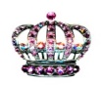
Base Package (Beauty Wear & OOC) $60.00 WANT IT ALL (Beauty Wear, OOC, Photogenic & Portfolio) $85.00
Optional Categories: Per Child Prices

Photogenic: $10 Portfolio: $15
Bring one NATURAL HEADSHOT photo 5x7 – 8x10 only, in a sheet protector. Write name and age division on back of picture. Light Make up is allowed, but keep it age appropriate. Bring the day of the pageant.
Bring 7-10 NATURAL photos 5x7 – 8x10 only, in a binder or folder with sheet protectors. Can be headshot or full body. Requires Cover Sheet with Name, Age & Any Additional Info. Light Make up is allowed, but keep it age appropriate. Bring the day of the pageant.

Mail this entry form and Check (Payable to Amanda Leystra) or Money order to PO BOX 384, Calvert, TX 77837
Forms must be RECEIVED no later than 10 days prior to the event you wish to enter.

Glitzy Girls of Texas
Emcee Information
Emcee will read this information while the contestant is on stage.
Contestant Information:
Contestant Name: _________________________________________________________________
Parent(s) of Contestant: _____________________________________________________________
Address: _________________________________________________________________________
Phone: ________________________ Email: ____________________________________________
Pageant Division (Please Circle One):
Baby Miss (0-14mo) Toddler Miss (15-23mo) Tiny Miss (2-3yrs) Little Miss (4-6yrs)
Junior Miss (7-9yrs) Pre-Teen Miss (10-13yrs) Teen Miss (14-18yrs)
Baby Mister (0-3yrs) Little Mister (4-7yrs) Junior Mister (8-12yrs)
Contestant Characteristics:
Hair Color: ________________________ Eye Color: _________________________
Favorite Things to do: _________________________________________________________
When I Grow Up, I Want to Be: __________________________________________________
Hobbies/Special Interests: _____________________________________________________
____________________________________________________________________________
Something That Makes Me Unique: ______________________________________________
Special Comments: ___________________________________________________________

